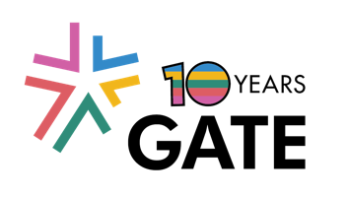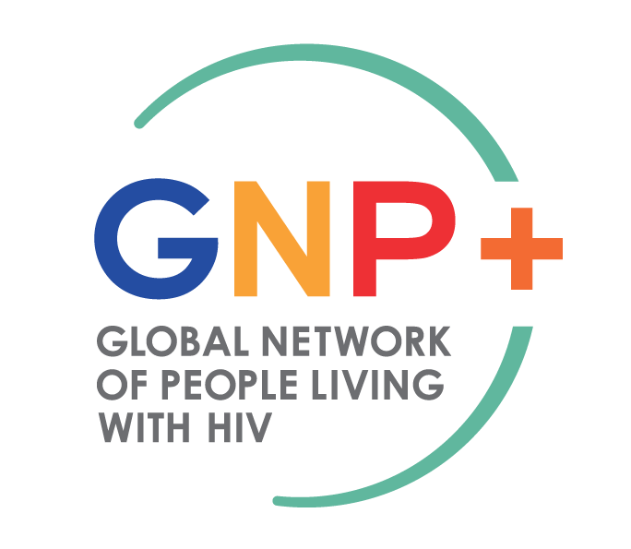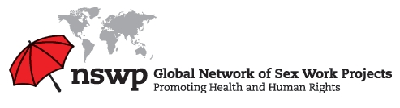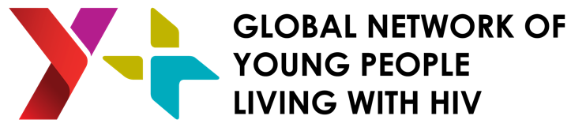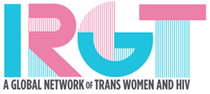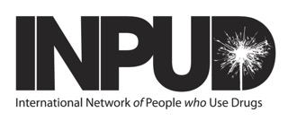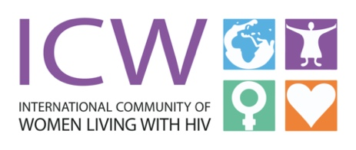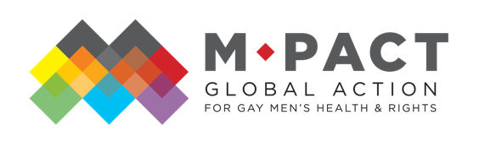

World AIDS Day 2020: Centering Key Populations in the Global HIV Response
December 1, 2020

Today, we commemorate World AIDS Day in support of people living with and affected by HIV, and to remember and celebrate those who lost their lives to AIDS. The global key population-led networks* – Global Action for Trans Equality (GATE); Global Network of People Living with HIV (GNP+); Global Network of Sex Work Projects (NSWP); Global Network of Young People Living with HIV (Y+ Network); Innovative Response Globally for Trans Women and HIV (IRGT); International Network of People Who Use Drugs (INPUD); International Community of Women Living with HIV (ICW); MPact Global Action for Gay Men’s Health and Rights (MPact) - issue this joint statement in solidarity with this year’s World AIDS Day theme: “Global solidarity, shared responsibility.”

This year, we commemorate World AIDS Day in the shadow of the COVID-19 pandemic, a global health crisis that has caused immense human misery and economic insecurity. Despite the devastation caused by the ongoing pandemic, we call on global policymakers and donors to not lose sight of their goal to end the HIV epidemic, which is now entering its fifth decade. The epidemic continues to disproportionately devastate our communities.

The HIV response is seriously off-track, particularly in curbing new HIV infections among key populations - gay and bisexual men, people who use drugs, sex workers, and transgender people - who have carried an inordinate burden since the beginning of the epidemic and who have been systematically denied rights, equity, and justice in the global HIV response.

Recent data indicates that, while there has been some progress in reducing new infections among some populations, 62% of new HIV transmissions in 2019 occurred among key populations and their sexual partners. Clearly, key populations continue to be disproportionately impacted by HIV. In comparison to the general population, the likelihood of acquiring HIV is greater for sex workers (x30), people who use drugs (x29), gay men (x26), and transgender people (x13).

Furthermore, the global target for HIV treatment will not be met by 2030 unless significant changes are made to the current HIV response. Only 59% of people living with HIV globally have a suppressed viral load. Almost a third of people living with HIV are not yet accessing antiretroviral therapy. To ensure that people living with HIV are able to live healthier and longer lives, and to prevent the further spread of HIV, it is critical that all people living with HIV be able to access high quality treatment services, to be retained in care, and to achieve an undetectable viral load.

Due to structural barriers such as criminalization, stigma, poverty, violence, and inadequately resourced programs, our communities struggle to access needs-focused and people-centered healthcare and HIV services. Discriminatory laws, policies, and practices further jeopardize the health outcomes and human rights of our communities. If these inequities are not addressed, the HIV epidemic will continue to cost people their lives and livelihoods.

The next year provides a critical opportunity for key populations to reclaim the HIV response. UNAIDS, the Global Fund, and PEPFAR are all updating their program and funding strategies in 2021. These and other multilateral and bilateral donors must do more to address the inequities that have devastated key population communities and resulted in unabating HIV epidemics worldwide among gay and bisexual men, people who use drugs, sex workers, and transgender people. We demand that global policymakers and donors urgently address these issues when developing their HIV strategies and funding priorities:

- Address structural barriers: Decriminalization and addressing stigma and discrimination against key populations is integral to achieving an effective and sustainable HIV response. We urge donors to support community-led efforts to decriminalize sex work, drug use, and consensual same-sex relations, and to ban discrimination based on sexual orientation and gender identity. Donors should also actively work with communities and governments to end gender inequality.
- Sharply increase funding targeted to key populations: Donor and national government investments in key population-tailored HIV prevention and treatment programs are grossly inadequate in proportion to the HIV disease burden of these communities. A recent study reported that a mere 2% of overall HIV funding is targeted at key population communities. This is unacceptable. Donors must earmark funding and develop funding streams and mechanisms specific to key populations-led organizations.
- Put the last mile first: Key populations already play a central role in ensuring the affordability and accessibility of HIV drugs and services for all, including people living at the margins of societies. Donors should recognize this by meaningfully and respectfully engaging with key populations to ensure tailored, evidence-informed, and rights-based sexual health services. They should review existing strategies to engage with key populations at all levels of decision-making and find ways to broaden and deepen these partnerships. Finally, donors should refrain from imposing unduly burdensome policies and targets that can undermine the ability of key population-led organizations and networks to do their work.
- Remember our past: We must not forget that HIV is about people. The principles of the Greater Involvement of People Living with HIV (GIPA) and “nothing for us without us” are critical elements of an effective and ethical HIV response. Donors, national governments, and civil society stakeholders should ensure that these principles are central to who key populations are and what we do, and to ensure our inclusion and visibility in programming and funding decisions.

The HIV2020 Online Conference: Reclaiming the Global Response, which was co-organized by some of the global key population-led networks, is hosting its final event today on World AIDS Day. This conference is a successful example of how, when, and why key population communities, armed with the necessary knowledge, funding, skills, and experience, can lead collective efforts to address the HIV epidemic.

As we approach 2021, we are poised to redouble our efforts to break down barriers to HIV prevention and treatment access for our communities, to fight for our human rights, and to work towards reclaiming our rightful role in leading the HIV response to counter the risks, threats, and crises that directly affect us. We look forward to doing so in coalition and in solidarity with our partners across the world.

